Business Requirements Document(BRD) Template
Project/Initiative
Month 20YY
Version X.XX

Company Information

Document Revisions
Date | Version Number | Document Changes
25/05/2026 | 0.1 | Initial Draft

Approvals
Role | Name | Title | Signature | Date

Introduction

Project Summary

Objectives
[These should describe the overall goal in developing the product, high level descriptions of what the product will do, how they are aligned to business objectives, and the requirements for interaction with other systems.]
Release a hotel booking platform that should get at least 10.000 bookings within 3 months from the platform release date. The product’s main features will be:
- Hotel search and filtration of the search results
- Hotel booking process
- Personal platform user account management
- Hotel rating process and commenting functionality
- ‘Whishlist’ management and possibility to compare added favorite hotels
- Hotel booking confirmation mechanism

Background
[Provide a brief history of how the project came to be proposed and initiated, including the business issues/problems identified, and expected benefit of implementing the project/developing the product.]
Currently, TravelMate allows users to create booking for hotel rooms only via email / phone requests with no automation. Due to the absence of automation, users are searching for competitors that provide a hotel booking platform with a booking confirmation mechanism that boosts the booking speed in 2 times.
The booking platform with a new confirmation feature will allow hotels to review booking requests and confirm them before the reservation becomes final.
This will reduce operational issues and improve trust between guests and hotel partners.

Business Drivers
[List the business drivers that make development of this product important. These can be financial, operational, market or environmental.]

The development of this feature is driven by several business needs:
- Prevent double bookings
- Improve cooperation with hotel partners
- Increase customer trust in the platform
- Provide hotels with better control over reservations
- Reduce customer complaints related to booking issues
- Speed up and automate the booking process

Project Scope
[Describe what work is in scope for the project, and specifically what work is out of scope… beyond the current budget, resources and timeline as approved by the project stakeholders. This is designed to prevent “scope creep” of additional features and functions not originally anticipated.]
Feature: Hotel rating process and commenting functionality

In Scope Functionality
- User can leave a review after the visit.
- User can leave a 1-5 star rating to the hotel after the visit.
- User can modify the review (comment) he created within 24 hours since the moment of its creation.
- User can add photos to the review, 2MB max per review. Supported format: .jpg, .png.
- Hotel administrator receives a notification regarding a new review being left.
- Hotel administrator can leave an answer for the review.
- Hotel administrator can moderate reviews, delete reviews with inappropriate language.
- System shows the rating of the hotel based on the average stars rating.
- System creates reviews in the review section of the particular hotel page.
- System allows creating the review and rating only if the status of the user’s booking is ‘Checked out’
- System allows leaving ratings separately for each section, including: location, comfort, price/quality
- System shows the date the review was created on.
- System should show the next labels on the hotel page, if those were added to reviews: clean, high-quality, Wi-Fi, friendly personal, valid photos.
- System denies review modification attempts made after 24 hours since the moment of its creation.

Out of Scope Functionality
- The system sends an email notification to the email of the user, if they did not create any review and rating, in 24 hours since the user’s booking status is changed to ‘Checked out’.
- AI-generated review summaries.
- Automatic toxicity detection.
- Importing reviews from Google/Tripadvisor/Booking.com.
- Liking / disliking reviews.

System Perspective
[Provide a complete description of the factors that could prevent successful implementation or accelerate the projects, particularly factors related to legal and regulatory compliance, existing technical or operational limitations in the environment, and budget/resource constraints.]

Assumptions
- Hotels have access to the TravelMate hotel platform
- Hotel admins regularly check hotel reviews
- Internet connection is available for hotel admins
- Hotel admins are aware how to use the platform

Constraints
- The solution must be implemented within the current project timeline

Risks
- Hotels do not receive notifications for the new reviews
- The system does not update the status of the user’s booking in time, thus the users cannot leave a review as the 24-hour window passes away.

Issues

Business Process Overview
[Describe how the current process(es) work, including the interactions between systems and various business units. Include visual process flow diagrams to further illustrate the processes the new product will replace or enhance.
Use case documentation and accompanying activity or process flow diagrams can be used to create the description(s) of the proposed or “To-Be” processes.]

Current Business Process (As-Is)
At any point during or after deployment of web apps or web sites (internal or external) to support business activities, development/support teams may create and deploy widgets.
- CMS / database administrators for the employee portal use the CMS tool to create widgets. They can test widgets in the designated staging environment, then register them and deploy to production.
- Development teams may deploy widgets to development and testing environments set up for their development projects. They must check widget code into and out of the source code repository according to their projects’ development schedule.
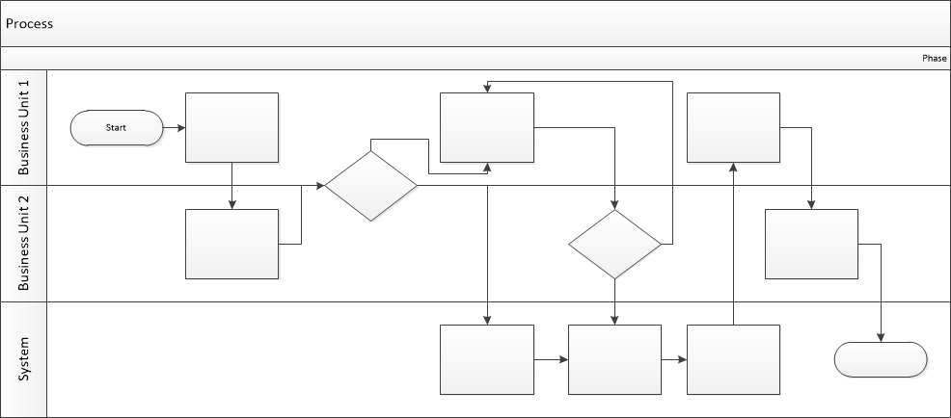

Proposed Business Process (To-Be)
- Technical Lead searches repository
- If widget is not found, user creates a new widget name record.
- WINS validates that all fields have been completed.
- WINS confirms that no similar widgets exist
- User confirms record to be created.

- User searches repository to locate existing widget description.
- WINS displays record
- User selects Edit to open and modify record
- WINS validates all fields completed correctly
- User confirms changes.
- WINS confirms changes and updates Audit table.


Stakeholder Requirements
[The specific user requirements elicited from stakeholders should be listed, categorized by both priority and area of functionality to smooth the process of reading and tracking them. Include links to use case documentation, and other key reference material as needed to make the requirements as complete and understandable as possible. You may wish to incorporate the functional and non-functional requirements into a traceability matrix that can be followed throughout the project.]

SR-001
Hotel administrator receives a notification regarding a new review being left.
SR-002
System allows creating the review and rating only if the status of the user’s booking is ‘Checked out’
SR-003
Hotel administrator can moderate reviews, delete reviews with inappropriate language.
SR-004
Hotel administrator receives a notification regarding a new review being left.
SR-005
Hotel administrator can leave an answer for the review.
SR-006
System shows the rating of the hotel based on the average stars rating.
SR-007
System allows leaving ratings separately for each section, including: location, comfort, price/quality.
The requirements in this document are prioritized as follows:
Value | Rating | Description
1 | Critical | This requirement is critical to the success of the project. The project will not be possible without this requirement.
2 | High | This requirement is high priority, but the project can be implemented at a bare minimum without this requirement.
3 | Medium | This requirement is somewhat important, as it provides some value but the project can proceed without it.
4 | Low | This is a low priority requirement, or a “nice to have” feature, if time and cost allow it.
5 | Future | This requirement is out of scope for this project, and has been included here for a possible future release.

Functional Requirements
Req# | Priority | Description | Rationale | Use Case Reference | Impacted Stakeholders
General / Base Functionality
FR-G-001 | 1 | User can leave a review after the visit. | Allows users to leave their impressions after the visit |  | Customers
FR-G-002 | 1 | User can leave a 1-5 star rating to the hotel after the visit. | Allows users to express their impressions after the visit in rating points |  | Customers
FR-G-003 | 2 | User can modify the review (comment) he created within 24 hours since the moment of its creation. | Allows users to correct typos, mistakes in the created review |  | Customers
FR-G-004 | 2 | User can add photos to the review, 2MB max per review. Supported format: .jpg, .png. | Ensures the users can share photos from their visit. |  | Customers
FR-G-005 | 1 | Hotel administrator receives a notification regarding a new review being left. | Ensures hotels are aware of the new reviews |  | Hotel admin
FR-G-006 | 1 | Hotel administrator can leave an answer for the review. | Ensures the hotels can react on the user’s reviews |  | Hotel admin
FR-G-007 | 1 | Hotel administrator can moderate reviews, delete reviews with inappropriate language. | Allows the hotels to delete the comments with abusive language |  | Hotel admin
FR-G-008 | 1 | The system shows the rating of the hotel based on the average stars rating. | Ensures the rating of the hotel is well-grounded and is traceable |  | Customers and Hotel owner
FR-G-009 | 1 | The system creates reviews in the review section of the particular hotel page. | Ensure the reviews are correctly displayed on the related page |  | Hotel admin
FR-G-010 | 1 | The system allows creating the review and rating only if the status of the user’s booking is ‘Checked out’. | Ensures that the reviews are created by the actual hotel visitors |  | Customers
FR-G-011 | 3 | The system allows leaving ratings separately for each section, including: location, comfort, price/quality. | Allows users to leave their impressions by several key parameters |  | Customers
FR-G-012 | 1 | The system shows the date the review was created on. | Ensures the users are aware of the hotel’s current state and what was upgraded |  | Customers and Hotel owner / admin
FR-G-013 | 3 | The system should show the next labels on the hotel page, if those were added to reviews: clean, high-quality, Wi-Fi, friendly personal, valid photos. | Allows users to see specific labels on the hotel page based on the review labels |  | Customers
FR-G-014 | 2 | The system denies review modification attempts made after 24 hours since the moment of its creation. | Prevents abusive comments modification |  | Customers
Security Requirements
FR-S-001 | 1 | Only authorized hotel administrators can reply on the reviews | Ensures on the hotel admins can create replies for the existing reviews |  | Hotel admin
FR-S-002 | 1 | Only authorized hotel administrators can moderate (delete) the reviews | Ensures on the hotel admins can delete the existing reviews |  | Hotel admin
Reporting Requirements
FR-R-001 | 1 | The system should record review / rating creation and modification actions in the audit log. | Ensures on the hotel admins can create replies for the existing reviews |  | Hotel admin
Usability Requirements
FR-U-001 | 1 | The reviews moderation interface must be simple and easy for hotel staff to use. | Makes sure the hotel admins are able to delete comments |  | Hotel admin
FR-U-002 | 1 | The reviews commenting interface must be simple and easy for hotel staff to use. | Makes sure the hotel admins are able to comment on the existing reviews |  | Hotel admin
Audit Requirements
FR-A-001 | 1 | The system must record the date, time, and user who commented on an existing review or deleted the review. | Ensures the hotels can track the logs of comments / deletions of the existing reviews |  | Hotel admin

Non-Functional Requirements
[Include technical and operational requirements that are not specific to a function. This typically includes requirements such as processing time, concurrent users, availability, etc.]
ID | Requirement
NFR-001 | The system must ensure secure authentication for hotel administrators
NFR-002 | Review data must be stored securely in the database
NFR-003 | The system should update the user’s booking statuses in less than 2 seconds
NFR-004 | System availability must be at least 99.5%
NFR-005 | The system must support at least 100 concurrent review creation requests

Appendices

List of Acronyms
[If needed, create a list of acronyms used throughout the BRD document to aid in comprehension.]

Glossary of Terms
[If needed, identify and define any terms that may be unfamiliar to readers, including terms that are unique to the organization, the technology to be employed, or the standards in use.]

Related Documents
[Provide a list of documents or web pages, including links, which are referenced in the BRD.]

